**BUSINESS**

**REQUIREMENTS SPECIFICATION**

**Citizen Feedback & Reporting System**

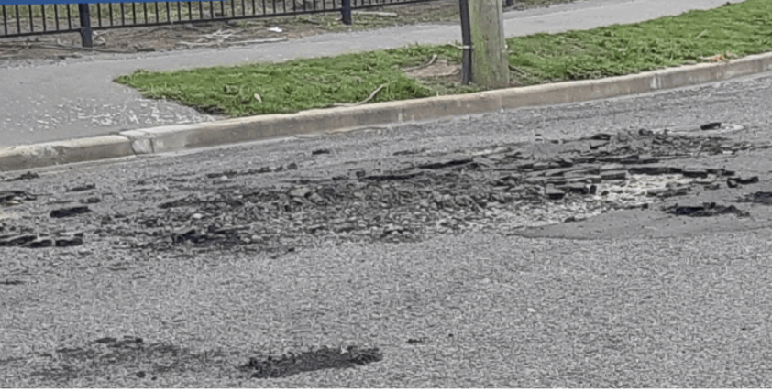

|  |  |
| --- | --- |
| **Document Author:** | *Sharon Cheethayil Sasidharan* |
| **Version Number:** | *001* |
| **Last Updated:** | *04/09/2024* |
| **Status:** | *Draft* |

**Table of Contents**

1 Introduction 3

2 Problem/Impact/Successful Outcome 3

3 Objectives 3

4 Purpose Of Document 3

5 Scope 4

6 Definitions, Acronyms and Abbreviations 4

7 Risks 4

8 Assumptions 5

9 Issues 5

10 Dependencies 5

11 As Is Process 5

12 Context Diagram 5

13 Process Overview Diagram 5

14 High Level To Be Business Requirements 6

15 Detailed Business/IT Requirements 7

15.1 Functional Requirements 7

15.2 Process Diagram 7

15.3 Non-Functional Requirements 7

16 Business Impact Assessment 8

17 Costs 8

18 Appendices 8

# Introduction

The Citizen Feedback and Reporting System is designed to allow residents of the Northern Territory to easily report non-emergency issues, such as potholes, graffiti, or broken streetlights, directly to local authorities. This application aims to enhance community engagement and streamline the issue resolution process by providing a user-friendly platform for citizens to submit reports, and for government officials to manage and address these reports effectively. The system is expected to improve the quality of municipal services, reduce response times, and provide transparency in handling community issues.

# Problem/Impact/Successful Outcome

|  |  |  |
| --- | --- | --- |
| **The Problem** | **The Impact** | **The Successful Outcome** |
| Currently, citizens lack a streamlined and accessible method to report non-emergency issues to local authorities. This often leads to underreported issues and delays in addressing community problems. | Without an efficient reporting system, issues such as potholes, graffiti, and broken infrastructure remain unresolved for extended periods, negatively impacting public satisfaction and community safety. | A successful outcome would involve the implementation of a digital platform where citizens can report issues quickly and easily, track the progress of their reports, and receive timely updates from authorities, leading to quicker resolutions and increased public trust. |

# Objectives

|  |  |  |  |
| --- | --- | --- | --- |
| **ID** | **Business Objective** | **Business Owner** | **Business Importance** |
| O01 | To create an accessible platform for reporting non-emergency issues. | NT Government | High |
| O02 | To improve response times and communication between citizens and local authorities by automating the report handling process. | NT Government | High |
| O03 | To enhance transparency and accountability in addressing community concerns by providing citizens with status updates on their reports. | NT Government | High |

# Purpose Of Document

The Business Requirements Specification (BRS) outlines the requirements for the Citizen Feedback and Reporting System. It aims to capture all necessary business needs in a structured manner that facilitates review and approval by stakeholders. This document serves as the foundation for designing a solution that meets the identified requirements, ensuring that the implemented system addresses the community's needs effectively.

# Scope

|  |  |
| --- | --- |
| **In Scope** | **Out Of Scope** |
| **1.** Development of a web application for citizens to submit feedback and report non-emergency issues.  **2.** Creation of an admin dashboard for officials to manage and respond to reports.  **3.** Integration of a notification system for updating report statuses. | **1.** Development of a mobile application.  **2.** Integration with other existing government systems beyond basic notifications and report management.  **3.** Real-time location tracking or advanced analytics. |

# Definitions, Acronyms and Abbreviations

|  |  |
| --- | --- |
| **Abbreviation/Acronym** | **Description** |
| UI | User Interface |
| API | Application Programming Interface |

# Risks

|  |  |  |  |
| --- | --- | --- | --- |
| **Ref** | **Risk** | **Detailed BRS Reference** | **Detailed Description** |
| R01 | Delays in official response times might lead to citizen dissatisfaction. | Functional Requirements | If government officials do not respond promptly to the feedback and reports, it could lead to frustration and dissatisfaction among citizens, reducing trust in government services. |
| R02 | Technical issues such as server downtime could prevent citizens from submitting reports. | Non-Functional Requirements | Technical problems like server downtime or software bugs can disrupt system availability, preventing citizens from submitting reports, leading to missed issues and reduced reliability. |
| R03 | Data breaches or unauthorized access could compromise sensitive citizen information. | Non-Functional Requirements | Security breaches, such as unauthorized access to the system, could expose sensitive data, undermining trust in the government’s ability to safeguard information. |

# Assumptions

|  |  |  |
| --- | --- | --- |
| **Ref** | **Assumption** | **Detailed BRS Reference** |
| A01 | Officials will actively monitor and update the status of reports. | Functional Requirements |
| A02 | Citizens will have reliable internet access to use the platform effectively for submitting feedback and tracking report statuses. | Non-Functional Requirements |
| A03 | The system will be adequately maintained, with regular updates and bug fixes, to ensure continuous operation and reliability. | Non-Functional Requirements |

# Issues

|  |  |  |
| --- | --- | --- |
| **Ref** | **Issue** | **Detailed BRS Reference** |
| I01 | Potential lack of citizen awareness about the new system. | High Level to Be Business Requirements |

# Dependencies

|  |  |  |
| --- | --- | --- |
| **Ref** | **Dependency** | **Detailed BRS Reference** |
| D01 | Internet connectivity for both citizens and officials to access the system. | Functional Requirements |
| D02 | Availability of technical support and maintenance services to address any system issues, updates, or downtimes promptly. | Non-Functional Requirements |

# As Is Process

Currently, citizens must either call or visit local government offices to report non-emergency issues, leading to inefficiencies and delays in addressing community concerns. This manual process lacks transparency and often results in unreported issues remaining unresolved.

# Context Diagram

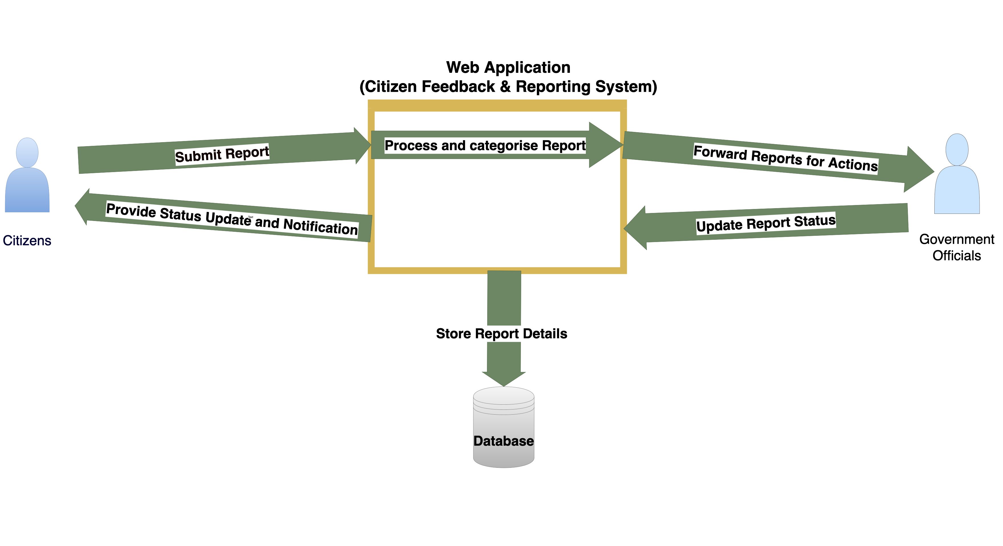

# Process Overview Diagram

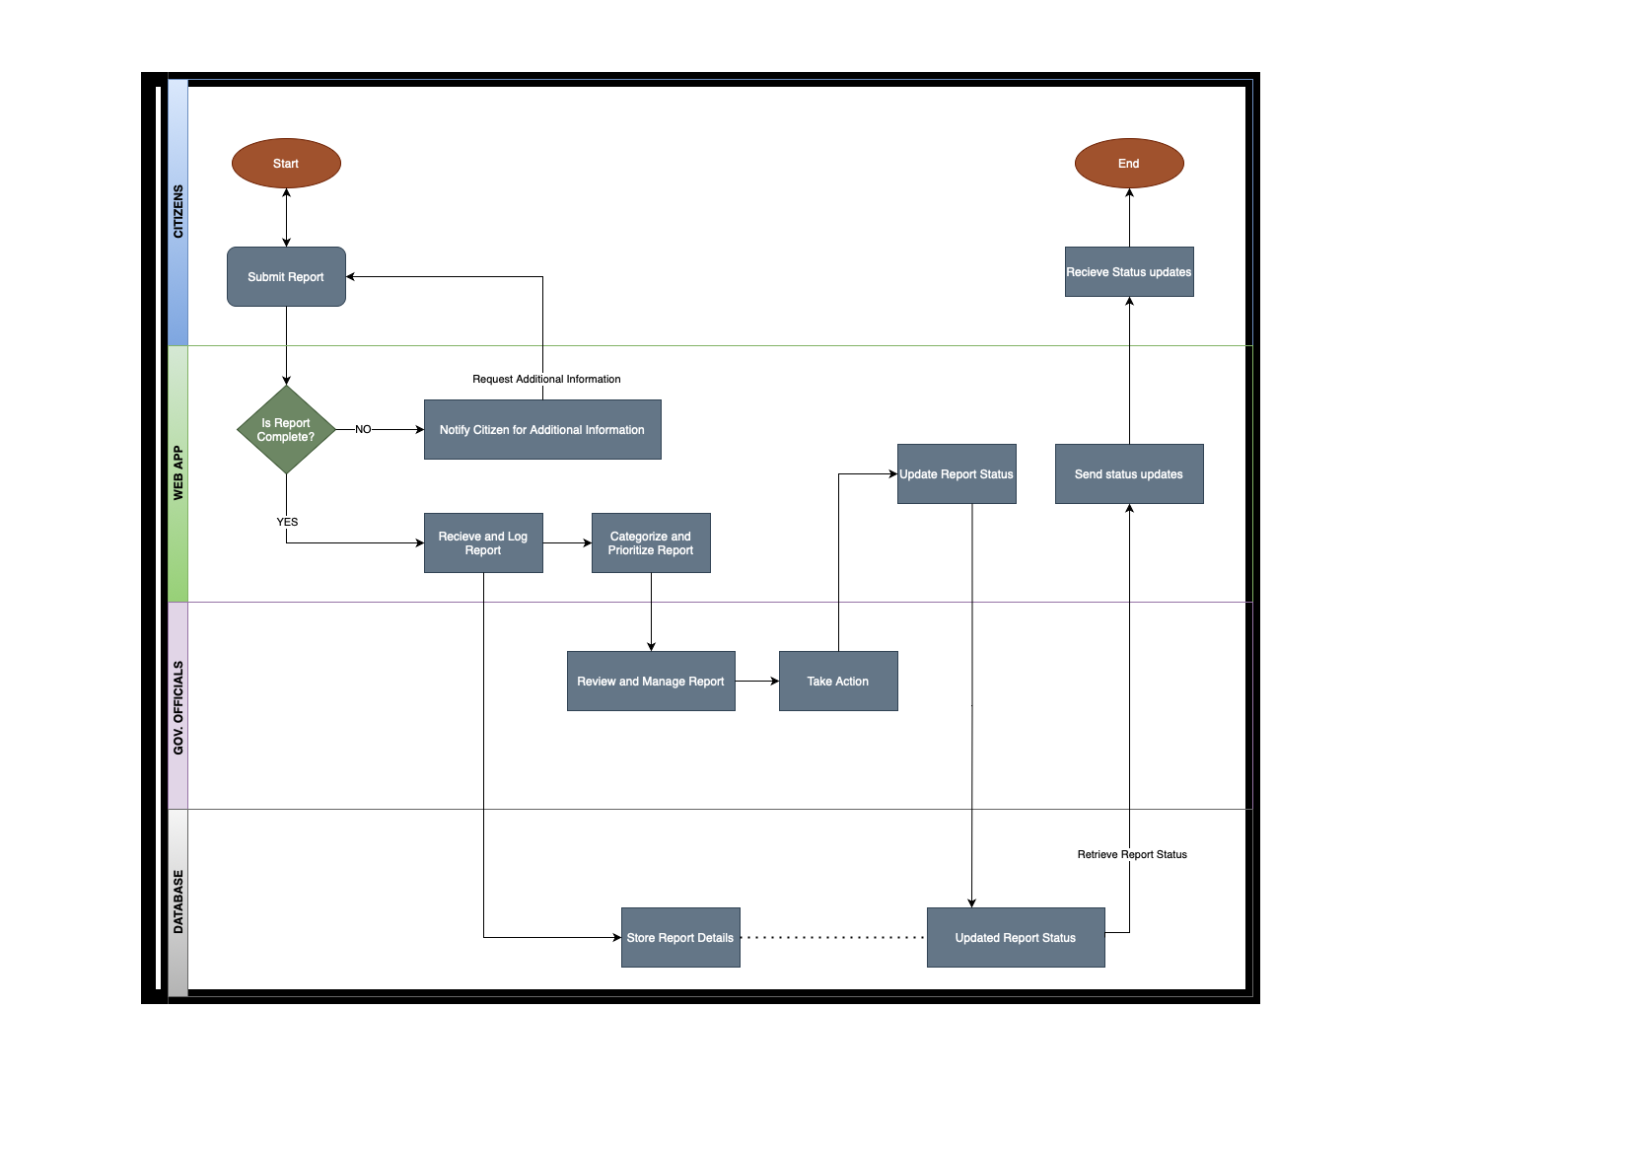

# High Level To Be Business Requirements

The To Be requirements focus on creating an efficient, accessible platform for citizens to report issues, and an administrative backend for government officials to manage and address these reports. The system should facilitate timely communication and transparent tracking of issue resolution.

## User Personas

**Persona 1:**

**Emma Thompson (Citizen)**

Age: 35

Occupation: School Teacher

Technology Use: Familiar with using smartphones and web applications.

Objectives:

To easily report non-emergency issues like potholes or broken streetlights within her community.

To monitor the progress of her submissions and receive timely updates on the actions taken.

To receive notifications on the status of her reports, ensuring she is informed about any developments.

Challenges:

Frustration with the lack of transparency and visibility in the current system regarding the progress of reported issues.

Prefers an intuitive, user-friendly interface that requires minimal effort to submit a report.

Scenario:

After noticing a broken streetlight near her residence, Emma accesses the Citizen Feedback & Reporting System via her smartphone. She submits a report, including a photo and description of the issue, and later checks the system for updates.

**Persona 2:**

**Mark Davis (Government Official)**

Age: 45

Occupation: Public Works Manager

Technology Use: Highly proficient with administrative and management software.

Objectives:

To efficiently review and manage incoming reports from citizens, assigning them to the appropriate departments.

To monitor the status of tasks assigned to ensure they are completed in a timely manner.

To provide updates on the reports to maintain transparency and keep citizens informed of the progress.

Challenges:

Balancing multiple responsibilities while ensuring prompt responses to citizen reports.

Requires a well-organized dashboard to manage high volumes of reports effectively, ensuring critical issues are prioritized.

Scenario:

Mark starts his day by logging into the admin dashboard, where he reviews new reports, assigns tasks such as fixing potholes, and updates the status of each report. Throughout the day, he monitors progress to ensure tasks are completed on schedule.

**Persona 3:**

**Sarah Lee (Technical Support Specialist)**

Age: 28

Occupation: IT Support Specialist

Technology Use: Expert-level proficiency, responsible for the maintenance and troubleshooting of the system.

Objectives:

To ensure the system operates smoothly with minimal interruptions.

To swiftly address any technical issues encountered by users, including citizens and government officials.

To maintain system security by performing regular updates and managing access protocols.

Challenges:

Handling unexpected technical issues that could disrupt the service.

Ensuring updates and maintenance do not negatively affect the user experience, particularly during peak usage times.

Scenario:

Sarah continuously monitors the system's performance and responds to alerts indicating potential issues. When a bug is detected affecting report submissions, she promptly resolves the problem and communicates the resolution to users.

# Detailed Business/IT Requirements

## Functional Requirements

|  |  |  |  |  |  |  |  |  |
| --- | --- | --- | --- | --- | --- | --- | --- | --- |
| **ID** | **Title** | **Requirements Description** | **Type (*)** | **MoSCoW Priority** | **Originator** | **Status (**)** | **Delivered By** | **Test ID** |
| FR001 | Feedback Submission | Citizens can submit feedback or report issues using a form on the website. | Application | Must Have | Stakeholder | Proposed | Development | T001 |
| FR002 | Status Tracking | Citizens can track the status of their reports through the application. | Application | Should Have | Stakeholder | Proposed | Development | T002 |
| FR003 | Admin Dashboard | Officials can view and manage incoming reports from citizens. | Application | Must Have | Stakeholder | Proposed | Development | T003 |
| FR004 | Notifications | Automated notifications to citizens about report status changes. | Integration | Should Have | Stakeholder | Proposed | Development | T004 |

## Process Diagram

*<Include a process flow diagram which links to the functional requirements above if necessary>*

## Non-Functional Requirements

|  |  |  |  |  |  |  |  |  |
| --- | --- | --- | --- | --- | --- | --- | --- | --- |
| **ID** | **Title** | **Requirements Description** | **Type (*)** | **MoSCoW Priority** | **Originator** | **Status (**)** | **Delivered By** | **Test ID** |
| NFR001 | Security | The system must have secure login and data handling processes. | Security | Must Have | Stakeholder | Proposed | Development | T005 |
| NFR002 | Performance | The system should handle up to 1000 concurrent users without performance degradation. | Performance | Should Have | Stakeholder | Proposed | Development | T006 |
| NFR003 | Usability | The interface should be intuitive and easy for citizens of all ages to navigate. | Usability | Must Have | Stakeholder | Proposed | Development | T007 |
| NFR004 | Availability | The system should be available 24/7, with maintenance windows scheduled during off-peak hours. | Availability | Must Have | Stakeholder | Proposed | Development | T008 |

# Business Impact Assessment

|  |  |
| --- | --- |
| **Lens** | **Key Impacts** |
| Process | The new system will automate the reporting process, reducing the need for manual data entry and follow-up by officials. This can lead to faster response times and more efficient handling of citizen reports. |
| People | Officials will need training to use the admin dashboard effectively. The system will also reduce the workload on frontline staff by providing a streamlined approach to handling citizen reports. |
| Customer | Citizens will have a more transparent and accessible way to report issues, which could improve public perception of government responsiveness. |
| Financial | Initial costs include development, implementation, and training. Long-term financial benefits may include reduced operational costs through improved efficiency and better resource allocation. |
| Data & MI | Data governance will be improved with structured data collection from citizen reports, enabling better analysis and decision-making. |
| Product & Proposition | The introduction of this system could lead to the development of additional digital services for citizens, expanding the government’s digital offerings. |
| Supplier | Any third-party suppliers providing components for the system must ensure compatibility and support during integration phases. |
| Management | Management will need to oversee the transition to the new system, including managing any changes in staff roles or responsibilities. |

# Costs

The estimated costs for the Citizen Feedback and Reporting System include development costs, maintenance costs, and potential training for government officials. Development costs cover the initial creation of the platform, including frontend, backend, and database integration. Maintenance costs encompass ongoing updates, bug fixes, and server costs. Training costs are associated with educating officials on using the admin dashboard and managing citizen reports

# Appendices

*<Additional document/s to add as a reference to the requirements>*